**About Me 3-Axis Accelerometer and Gyro Sensor (for Ultimate 2.0)**

[**https://support.makeblock.com/hc/en-us/categories/12060261766807-Products**](https://support.makeblock.com/hc/en-us/categories/12060261766807-Products)

FollowNot yet followed by anyone



[**Makeblock Technical Support Team**](https://support.makeblock.com/hc/en-us/profiles/360718836993-Makeblock-Technical-Support-Team)

March 06, 2023 04:14

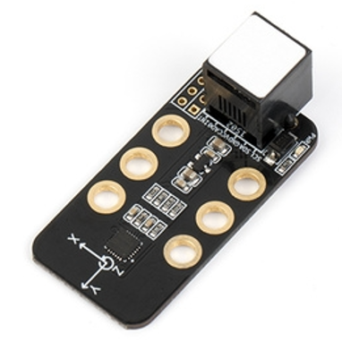

**Overview**

The Me 3-Axis Accelerometer and Gyro Sensor is an ideal module for robot motion and posture detection. It includes a 3-axis accelerometer, a 3-axis angular velocity sensor, and a motion processor, and provides I²C ports for communication. It can be installed on self-balancing cars, 4-axis aircraft, robots, and mobile devices. It features a high-dynamic measurement range and low current consumption. The white tag on the interface of this module indicates that it is an I²C communication interface and that it should be connected to a port with the white tag on the main control board.

**Specifications**

* Operating voltage: 5V DC
* Operating temperature: 0–70℃
* Signal mode: I²C communication
* Dimensions (L x W x H): 51 mm x 24 mm x 18 mm

**Features**

* The white zone on the module is for connection with metal beams;
* Digitally output 6-axis or 9-axis fusion calculation data in such formats as rotation matrix, quaternion, and Euler angle.
* Controllable measurement range of the 3-axis angular velocity sensor: ±250 deg/s, ±500 deg/s, ±1,000 deg/s, and ±2,000 deg/s;
* Controllable measurement range of the 3-axis accelerometer: ±2 g, ±4 g, ±8 g, and ±16 g;
* Digital Motion Processing (DMP) engine is provided to reduce the load of complex motion integration, sensor synchronization, and posture detection;
* Eliminate the axial sensitivity gap between accelerometer and gyro, reduce the influence of settings, and shrink the sensor drift range;
* Calibration algorithms for operation time difference and magnetic sensors are embedded in the module;
* Reverse connection of power does no harm to the IC;
* The module supports programming in Arduino IDE, and simplifies the programming process with a runtime library;
* The module supports block-based coding on mBlock 5 and mBlock 3, which is suitable for all ages;
* The connection is easy with the RJ25 connector;
* The module features modular installation, compatible with Lego parts.

**Pin Definition**

The connector of the line follower module has 4 pins. The features of the pins are shown in the following table.

|  |  |  |
| --- | --- | --- |
| SN | Pin | Feature |
| 1 | SCL | Support I²C communication (clock pin) |
| 2 | SDA | Support I²C communication (data pin) |
| 3 | GND | Connect the ground electrode |
| 4 | VCC | Connect the power cord |

**Wiring Mode**

● RJ25 cable

The tag color on the interface of the line follower sensor is white. When you use the RJ25 connector, you need to connect it to a port with the white tag on the main control board. Take Makeblock Orion as an example. You can connect it to port 3, port 4, port 6, port 7, or port 8 as shown in the following figure.

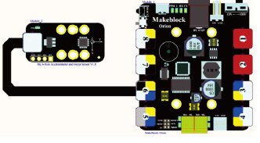

● Dupont cable

When you use a Dupont cable to connect to Arduino Uno, pin SCL and pin SDA of the module should be connected to I²C interfaces (namely port A4 and port A5) as shown in the following figure.

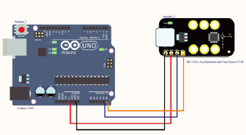

**Programming Guide**

● Program with mBlock 5

The Me 3-Axis Accelerometer and Gyro Sensor support programming with mBlock 5. The following is a brief description of a block on this module:

|  |  |
| --- | --- |
| Block | Features |
| output__22_.png | Select an axis Read the angle value of the gyroscope |

● Program with mBlock 3

The Me 3-Axis Accelerometer and Gyro Sensor support programming with mBlock 3. The following is a brief description of a block on this module:

|  |  |
| --- | --- |
| Block | Features |
| output__23_.png | Select an axis  Read the angle value of the gyro |

**●**Program in Arduino

If you program in Arduino, you need to use Makeblock-Library-master to control the Me 3-Axis Accelerometer and Gyro Sensor.

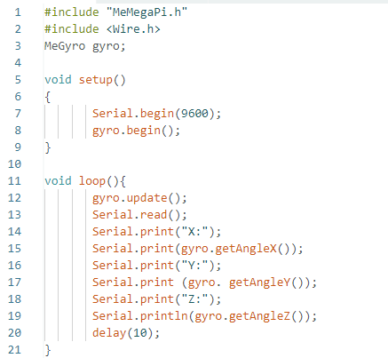

List of functions and features of the Me 3-Axis Accelerometer and Gyro Sensor:

|  |  |
| --- | --- |
| Function | Feature |
| double angleX() | Read the angle value of the x-axis |
| double angleY() | Read the angle value of the y-axis |
| double angleZ() | Read the angle value of the z-axis |
| void update() | Update the angle values |
| void begin() | Initialize the angle values |

This program is written in Arduino programming language. When you enter values on the serial monitor, the module receives the values and returns the angle values of the x-axis, y-axis, and z-axis. You can see the angle values of the x-axis, y-axis, and z-axis on the serial monitor from the serial monitor and know the posture of the module.

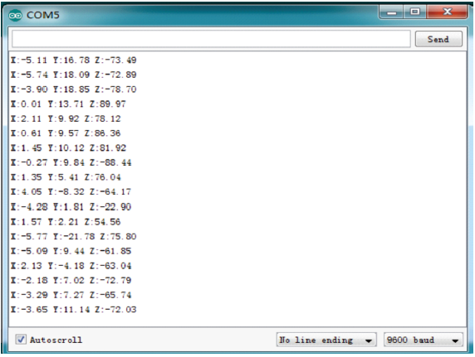

**Me 3-Axis Accelerometer and Gyro Sensor**

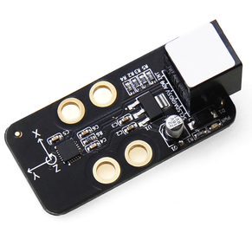

**Overview**

The Me 3-Axis Accelerometer and Gyro Sensor is an ideal module for motion and posture detection of robot. It includes a 3-axis accelerometer, a 3-axis angular velocity sensor, and a motion processor, and provides I2C port for communication. It can be applied on the self-balancing cart, 4-axis aircraft, robot, and mobile devices. It has the advantage of high-dynamic measurement range and low current consumption. Its white ID means that it’s in I2C communication mode and should be connected to the port with white ID on Makeblock Orion.

**Technical specifications**

* Input voltage: 5V DC
* Signal mode: I²C communication
* Module size: 51 x 24 x 18 mm (L x W x H)

**Functional characteristics**

* White area of module is the reference area to contact metal beams
* Digital output of 6-axis or 9-axis synthetical operation data of such formats as rotation matrix, quaternion, and Euler angle
* 3-axis angular velocity sensor controlled measurement range: ±250, ±500, ±1000, ±2000°/s (dps)
* 3-axis accelerometer controlled measurement range: ±2g, ±4g, ±8g, and ±16g
* Digital Motion Processing (DMP) engine is provided to reduce the load of complex motion integration, sensor synchronization, and posture detection
* Eliminate the axial sensitivity between accelerometer and gyro; reduce the influence of settings and drifting of sensor
* Embedded calibration algorithm of operation time deviation and magnetic force sensor
* Anti-reverse protection – connecting the power supply inversely will not damage IC
* Support mBlock GUI programming, and applicable to users of all ages
* Adopt RJ25 port for easy connection
* Provide pin-type of port to support most development boards including Arduino series

**Pin definition**

The port of Me 3-Axis Accelerometer and Gyro Sensor has 4 pins, and their functions are as follows:

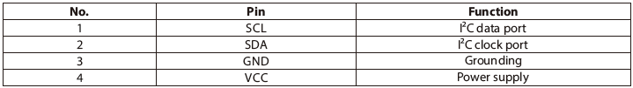

**Wiring mode**

● **Connecting with RJ25**

Since the port of Me 3-Axis Accelerometer and Gyro Sensor has white ID, you need to connect the port with white ID on Makeblock Orion when using RJ25 port. Taking Makeblock Orion as example, you can connect it to ports No. 3, 4, 6, 7, and 8 as follows:



● **Connecting with Dupont wire**

When the Dupont wire is used to connect the module to the Arduino UNO Baseboard, its SCL and SDA pins should be connected to I2C port, that is, the port A5 and A4 respectively as follows:



**Guide to programming**

● **Arduino programming**

If you use Arduino to write a program, the library Makeblock-Library-master should be invoked to control the Me 3-Axis Accelerometer and Gyro Sensor. This is a routine wrote in Arduino. When any value is input through the serial monitor, the module receives it and returns the current value of X, Y, and Z, so that we can identify the posture of current module. We can see the value of X, Y, and Z on the serial monitor.

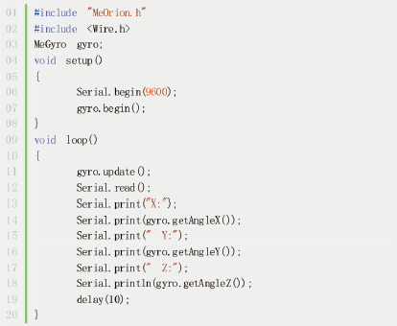

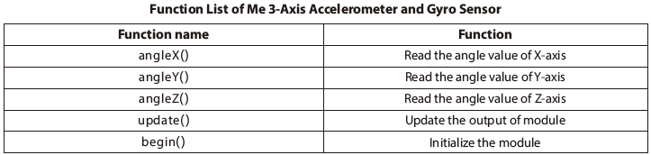

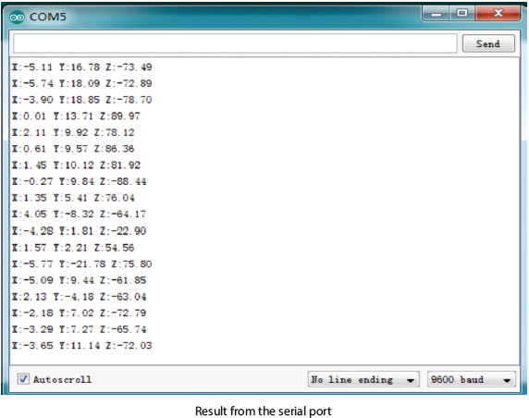

● **mBlock programming**

Me 3-Axis Accelerometer and Gyro Sensor supports the mBlock programming environment and its instructions are introduced as follows:

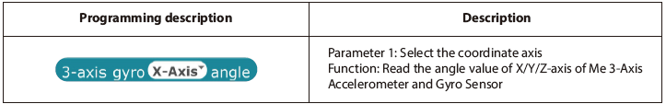

The following is the effect to make the panda speaking out the value of X/Y/Z of Me 3-Axis Accelerometer and Gyro Sensor.

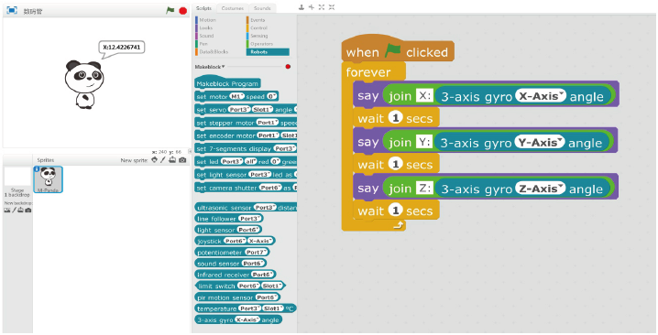

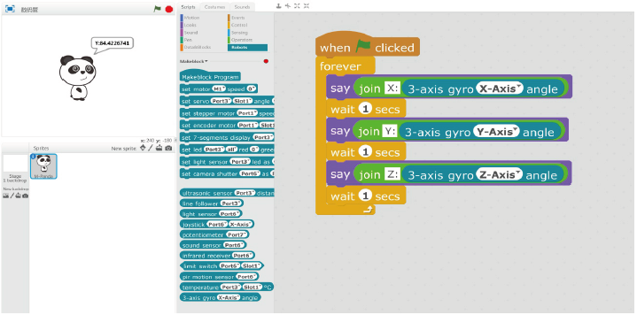

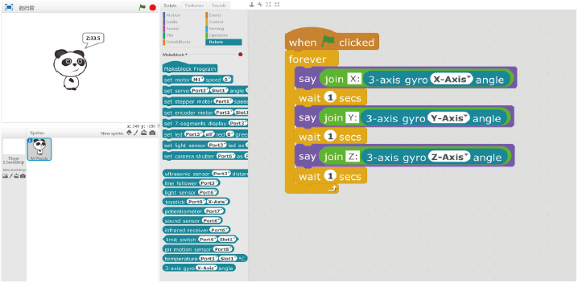

**Principle analysis**

The Me 3-Axis Accelerometer and Gyro Sensor integrates a 3-axis accelerometer, a 3-axis angular velocity sensor (gyro), and a Digital Motion Processing engine (DMP), and outputs integrated 9-axis synthetical data to application client in the form of single data stream from the I2C port.

The 3-axis accelerometer can measure the change of acceleration in X, Y, and Z axes. By perceiving the total inertial force in a specific direction, the accelerometer can measure the acceleration and gravity.

The 3-axis accelerometer means it can detect the motion or gravity of an object in 3D space. The accelerometer can be used to measure the gravity g. If the module is still and completely motionless, the force that the earth gravity exerts on it is about 1 g. If it is placed vertically, it will detect the force exerting on it along Y-axis is about 1 g. If it is placed at a certain angle, it will detect that the force of 1 g distributes on different axis. When it is in motion or vibration in 3D space, the Me 3-Axis accelerometer and Gyro Sensor will detect the force greater than 1 g in one or more axes, and acceleration as well. Velocity and displacement can be obtained by integrated the acceleration. When an object rotates around an axis, the angular velocity is generated. The 3-axis angular velocity sensor (gyro) can detect the change of angular velocity on X, Y, and Z axes. The motion processing engine can directly output data through I2C port, which reduces the burden of peripheral microprocessor and avoids complicated filtering and data synthesization.

**Schematic**

